1.

This is a time-series dataset. The feature in this dataset represents the date and 6 stocks (GOOG, AAPL, AMZN, FB, NFLX, MSFT) with their corresponding closing price in 2018/2019.

2.

3.

4c.

4d.

Two features should be removed. The reason is that when the threshold is 95%, there are two features that have cumulative explained variance ratio that higher than 95% (98.14% and 100%).

4e.

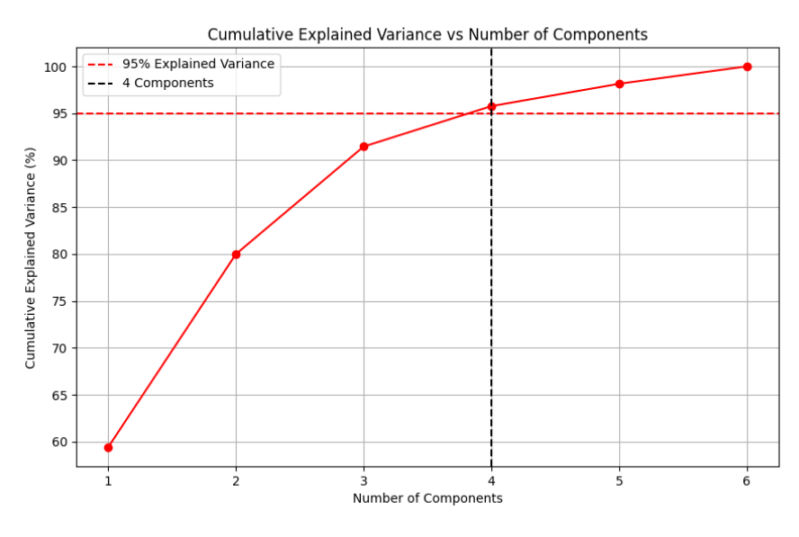

4f.

The singular values of the reduced feature space will be smaller compared to the original space because PCA removes low-variance components. The first few singular values remain relatively large, representing the retained variance in the dataset. Since PCA removes near-zero singular values (which contribute to multicollinearity), the condition number of the reduced dataset should be significantly lower, indicating a more numerically stable dataset. This confirms that PCA reduces redundancy and collinearity in the dataset.

4g.

The correlation values appear to be around 0.00, so the principal components are uncorrelated among each other.

4h.

4i.

4j.

4k.

